Carburetor Cleaning & Tuning 101

There are so many questions that are answered by cleaning or tuning your carbs so I decided to write up a "How to."
On a scale of 1-10, 10 being the hardest thing to do on a motorcycle, I rate Carb cleaning at a 4 and tuning at a 7. Some mechanical know how helps, but as long as you have the right tools, patience, and the willingness to learn, you will be fine.
On the pictures I have numbers. The numbers are not an order of which to do things, but just things I point out for you to keep note of.
This is just a guide to show you around the carburetor. A good tuning guide can be found at Factory Pro's website. Here is the link:
http://www.factorypro.com/tech_tunin...m_engines.html
Tools needed:
Screwdrivers - Flat head and Phillips, stubby and long
Pliers - not required but helps with pulling off some hose clamps
Wrenches - 7mm up to 12mm does most jobs on this bike.
Pilot screw adjuster - D shaped driver, but not needed with a little mod...
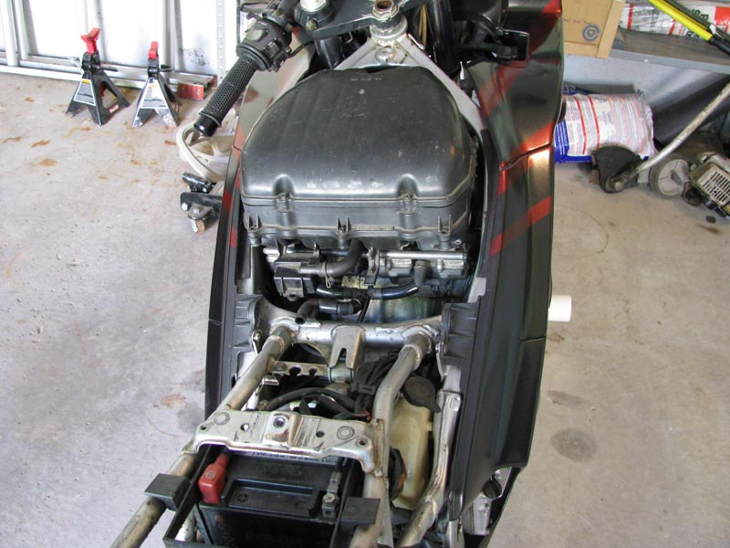
Remove Tail fairings, seat and gas tank (set the tank to OFF position first). If you can't get this far, then carbs are out of your league for the time being.
---
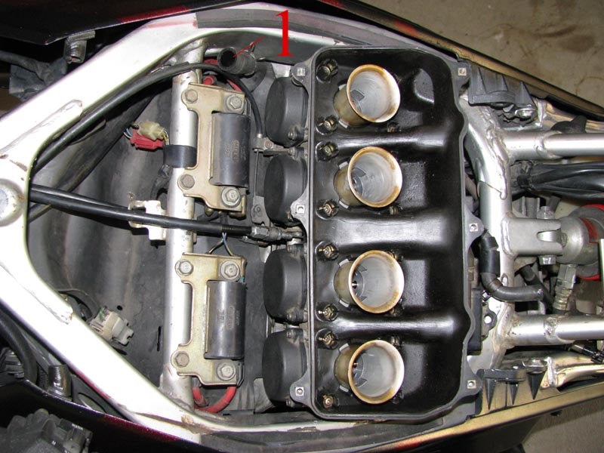
1. Breather hose - Be sure to reattach this when you put everything back together
Remove the air box cover, filter and everything else down to the carbs. Those only require a Phillips head, but an electric driver really speeds things up. As you can see there are a bunch of screws.
---
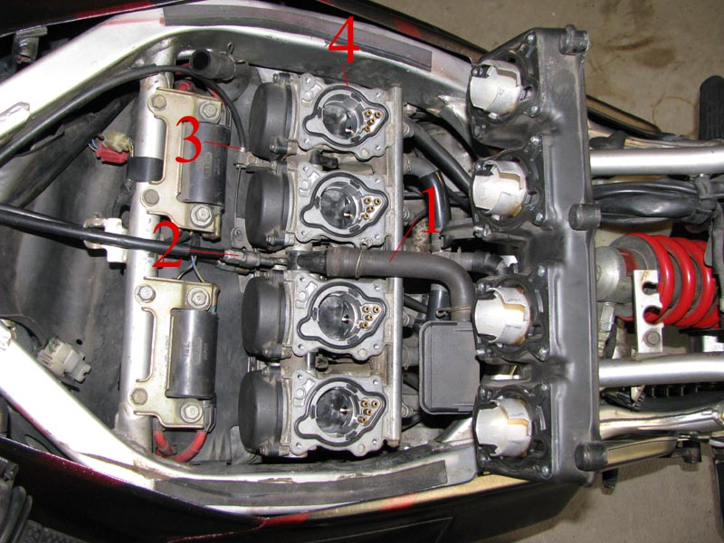
1. Another breather hose, pull it off and don't forget it later
2. Throttle cables
3. Choke cable
4. Gaskets, don't lose these
Pull off the rest of the air box
---
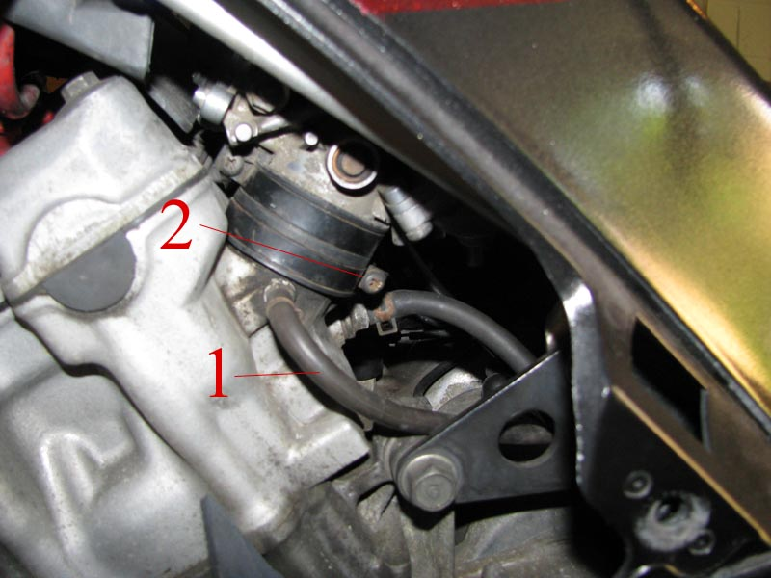
1. Vacuum hose that goes to the gas tank, another thing to not forget during reassembly
2. Carb Boot screw
Loosen up each screw on all four of these boots which are on the bottom of the carbs. They are a pain to get to. I use a stubby but I have small hands, you may need a long screw driver. Once loose, rock the carbs front to back to loosen them and pull up. This can be a chore if you have not taken them off for a while.
---
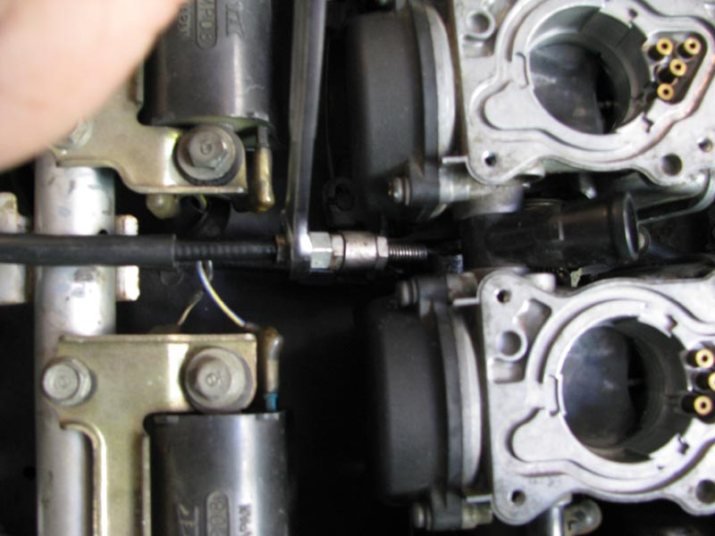
Now for the worst part of the job. Remove the throttle cables. Loosen up the throttle cables, slide them out of the holder and push the cable in closer toward the other end of the carburetor. This puts slack on the cable so that it is easier to remove.
---
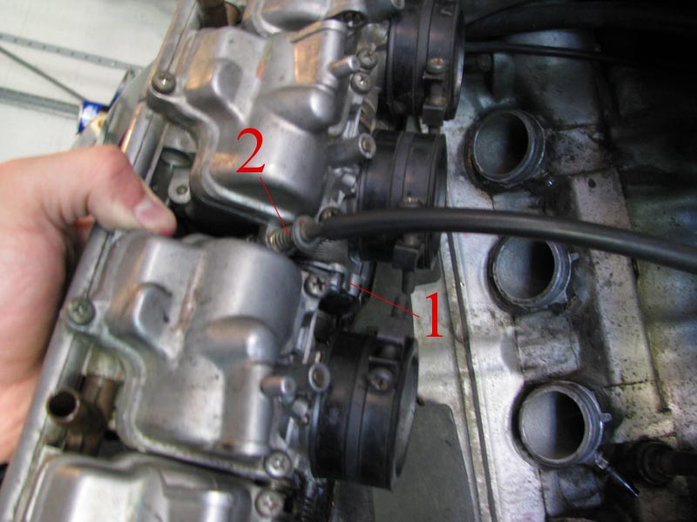
1. This is where the throttle cables are locked in.
2. Idle adjuster screw - Just so you know where it is... If you look, you can see what it does as well. It just slightly opens the throttle plate.
There is no easy way to explain how to remove the cables. It sucks and it's a pain in the arse. You need to put enough slack in the cables in order to slide them out of the little holder. Have fun.
---
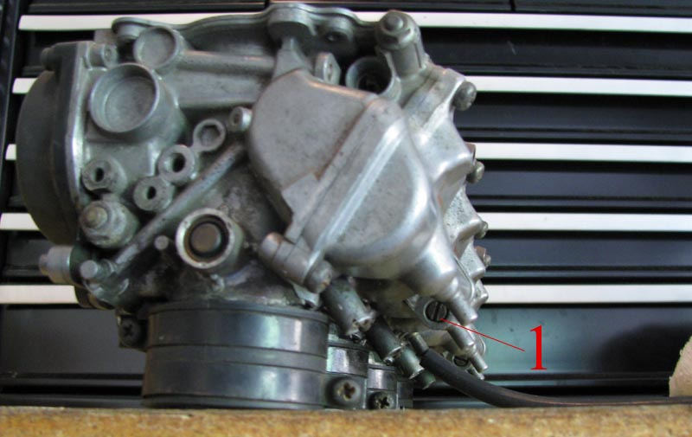
1. Float bowl drain screw
Unscrew all of these and let the fuel drain out of the bowls. Do it somewhere you don't mind getting messy.
---
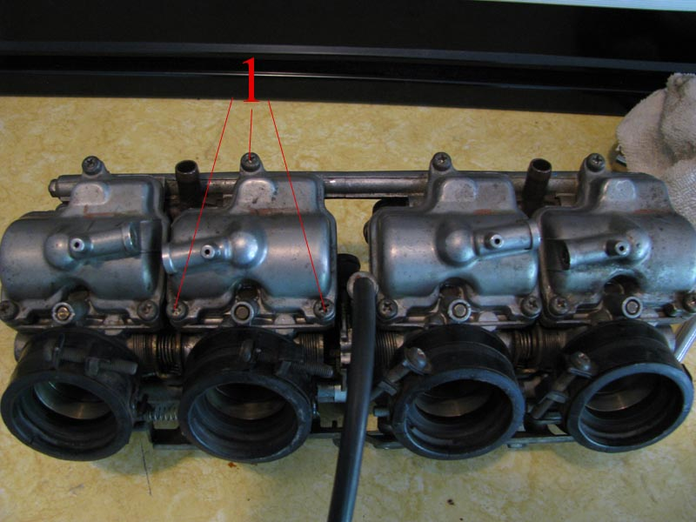
1. Float bowl screws
Take these out
---
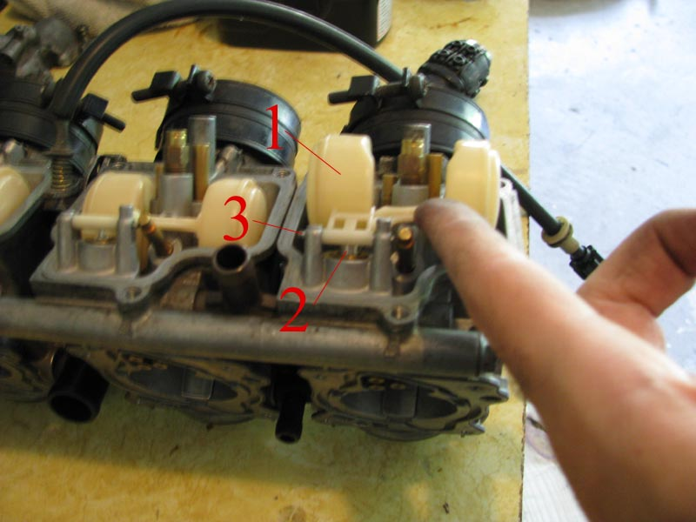
1. Float
2. Float valve
3. Float pin
Here is a common trouble area. The float and valve here are what regulate the fuel coming into the carbs. A bike that sits a few months without stabilizer in the carbs can get gunk in many places and this is a common one. Lift up on your floats gently and make sure the valve moves without sticking. If you are due for a cleaning, knock out the float pin in order remove the float and valve. Use carb cleaner and a scotchbrite pad to clean both the valve and the seat. Also the tip of the needle is rubber, be sure it still V shaped so that it seats properly.
---
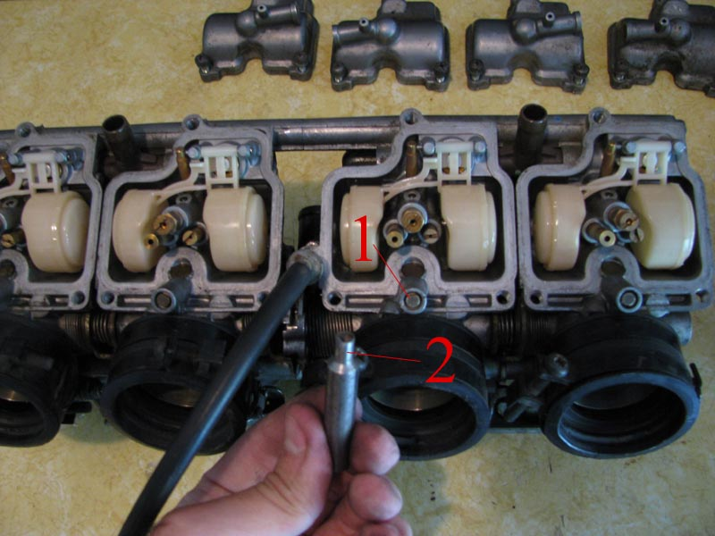
1. Pilot/Slow jet adjustment screw
2. D shaped adjuster tool. (Pilot Screw Wrench: 07908-4730001)
Pilot jets control how well your bike Idles, comes off of idle, and operates at cruising speed around 4k RPMs
*TIP* If you don't have one of these dumb tools, you can get a mini hack saw, or a hand grinder Dremmel tool type thing and cut in a small slit down the center of the Pilot screw. This makes it adjustable with a standard flat head screw driver.
Initial setting for Canada type: 2 turns out

---
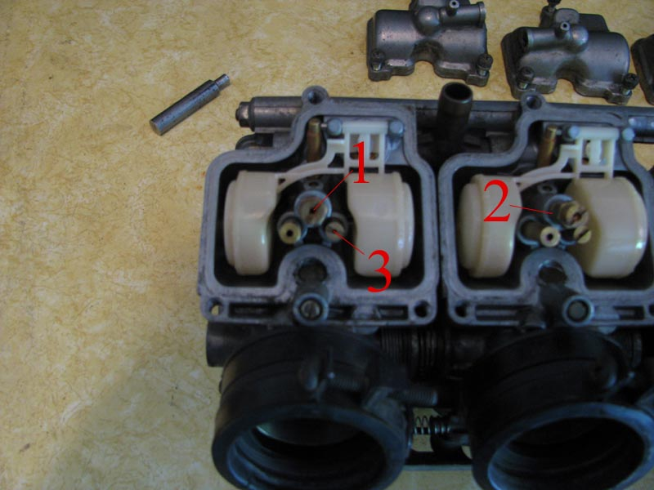
1. Main jet
2. Needle jet - Main jet screws into the top of this.
3. Pilot/Slow jet
More things to clean. Pretty much anything with a hole can get carb cleaner squirted into it and an air compressor is a very nice thing to have. It is not required but it makes everything 100x's easier. If you don't have an air compressor, I recommend unscrewing the 2 Jets with a flat head, then unscrewing the needle jet with a 7mm wrench and soaking all of them in carb cleaner over night.
WARNING! Do not get carb cleaner on anything non metal. It eats paint; it eats plastic; and destroys rubber!
---
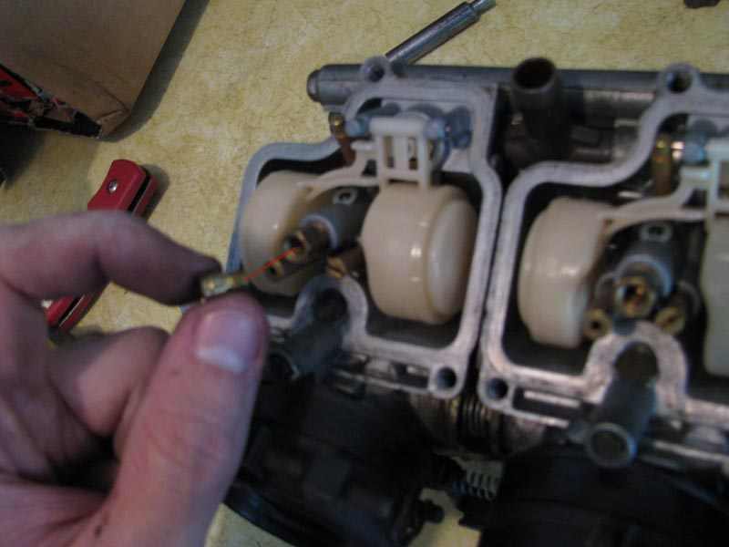
If you have a jet kit, this is 1 of the things you may have to tinker with. Main jets control the air/fuel mixture at high RPMS. There are numbers on the jets, a bigger number = a bigger hole which = more fuel.
When you are done here, screw it all back together. Be sure to put the float bowl gaskets back on or you will have a big mess later.
---
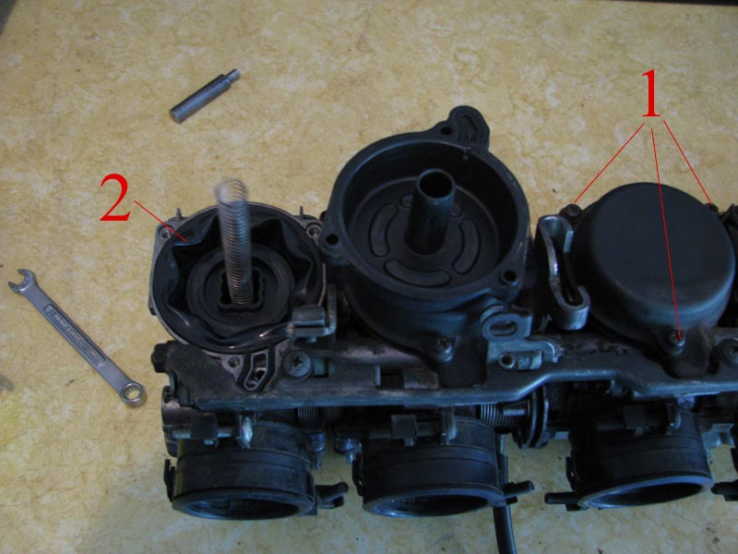
1. Vacuum chamber cover screws - Unscrew these
2. Diaphragm/Vacuum Piston
Unless your carbs have been sitting for years, you probably won't have to touch this side. No fuel enters here (maybe just a little mist) so not much gets gunked, however its rubber and can rot if neglected for years. This side is more for jetting
---
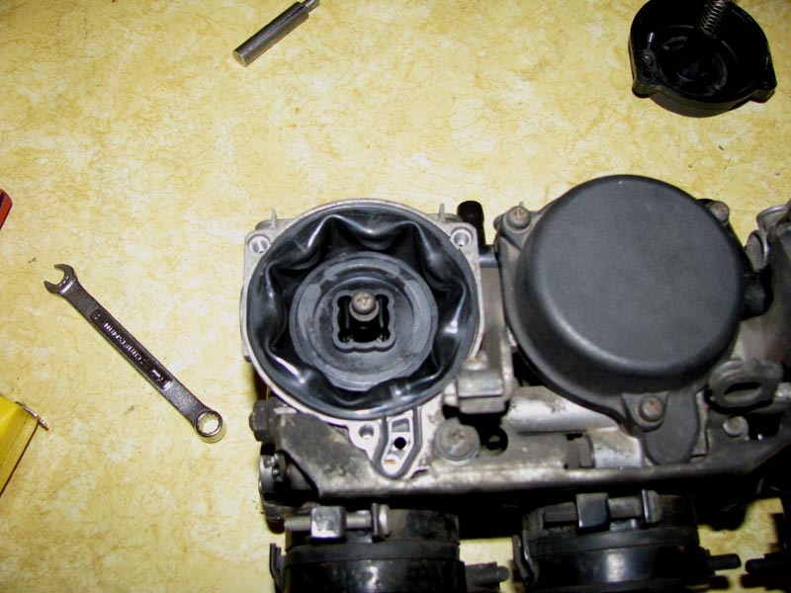
Hand screw one of the cover screws into the center of the diaphragm to remove it.
---
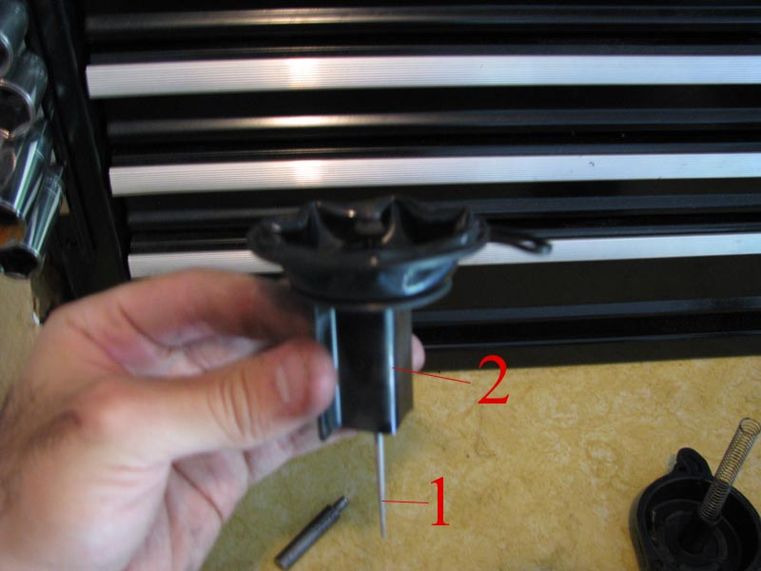
1. Jet needle
2. Vacuum piston/Slider
While holding on to the slider, be careful not to bend or break the needle, pull on the screw which you have threaded into the center of the diaphragm. Give it a good tug; nothing will break unless you smack the needle off something.
---
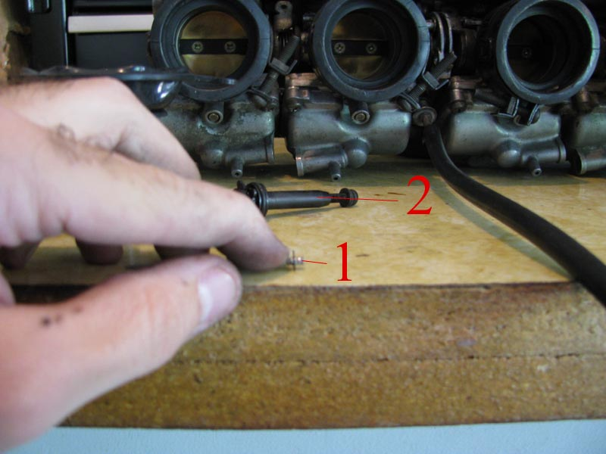
1. Multi slotted jet needle - this is aftermarket and what comes in a jet kit. The clip position on this controls the 5-7.5k RPM range.
2. Plate set - This is the thing you just yanked out of the slider.
This is where you find out if your carbs are OEM or you have a jet kit. ANY alteration to your bikes intake, engine, or exhaust will require a jet kit if you want your bike to function properly.
To change clip positions, lay the needle down on a table like in the picture. Feel free to use another finger on the other side of the clip, and push down. It is a C clip. Do the same thing in order to snap the clip in. Again, be gentle; do not bend your needles.
Jet kits also come with shims (little washers). These shims are used to alter the needle by half of a clip position. All you do is put a shim on the pointy side of the needle down to the clip and drop it back into the slider.
To assemble, just put the needle back in and snap the plate set down into place.
---
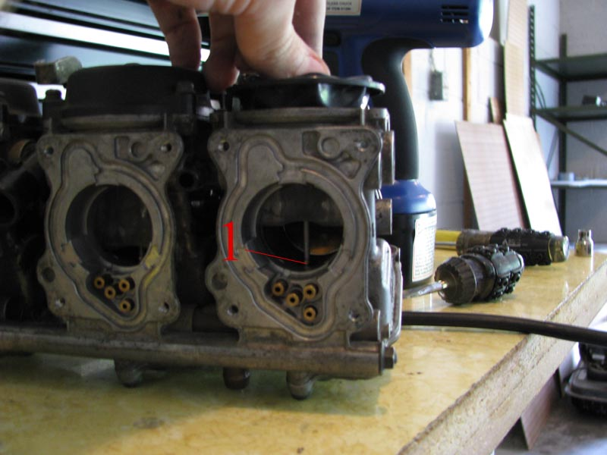
1. Jet needle sliding into needle jet.
Drop the slider gently back into place and be sure that the needle goes into the jet.
---
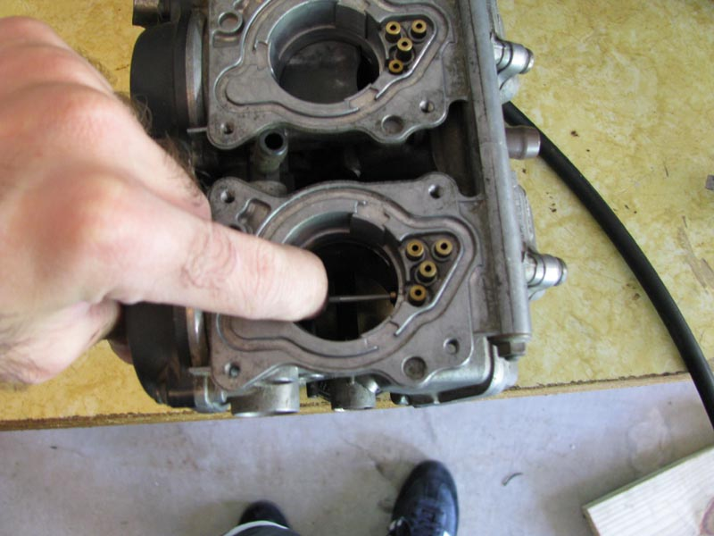
Screw the cover back on, and once you are done push down on the sliders, they should resist a little and slide back into position smoothly.
Warning! Do not over tighten ANYTHING on your carbs. Make everything snug but don't put all your might into it. The jets are a very soft metal and easy to ruin, and all of the cover screws can be stripped if you aren't careful.
At this point, you just start putting everything back together. Attach your choke and throttle cables (have fun with that again...), push the carbs down onto the engine and be sure they are seated properly and tighten up the boot screws. Attach your air filter box, breather hoses, air filter, gas tank (don't don't forget the vacuum and fuel lines), seat and fairings.
Edit: Adding a pic and link on reading spark plugs.
Below is a picture of my current spark plugs. This is the best tuning I have yet to achieve. It is tuned for horse power, and thus close to being lean. However, there are no signs of detonation, or over heating therefore it is still safe.
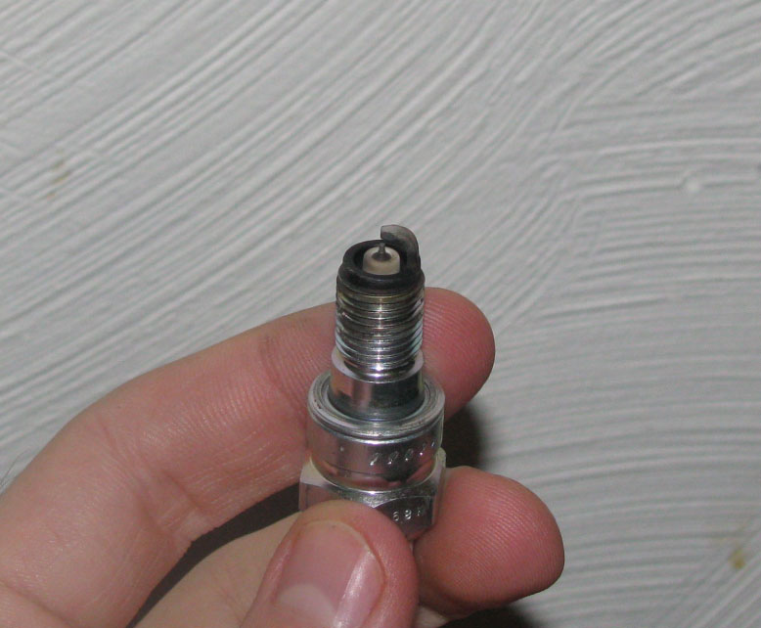
How to read spark plugs: http://www.angelfire.com/fl4/pontiac...Readplugs.html
Enjoy

