Rewinding SC24 Stator CBR1000F
This forum has helped me get my 31 year old damaged barn find rescued bike up and going. This tutorial is a small thank you to the good people on this CBR forum who willingly and unselfishly give us their time and deep knowledge to keep our motorcycles going.

Read First
Please note this tutorial applies only to the second gen oil cooled SC24 and not for the 87/88 first gen SC21. Unfortunately these are no longer factory made anywhere. So I suspect we'd all better get used to doing stuff like this ourselves.

Some Key Search Words:
Honda CBR1000F Hurricane SC24 LD125-52 stator generator alternator rewinding
Honda part number 31130-mt3-003 / 31130MT3003

Compatible Honda Motorcycles (visually check yours first)
- HONDA CBR1000F 1990-1996
- HONDA ST1100 1991-1995
- HONDA ST1100A 1992-1995
- HONDA CB1000 1994-1995
- HONDA CB750 NIGHTHAWK 1991-2003

Step Number One. If you can find a stator rewinding professional you can trust - do it. If the global postage system wasn’t in such disarray, mine would have gone straight to Roger Lovelock at Info@Bbbikeshop.Co.Uk who reconditions these for the SC24 – at a reasonable price.
Caveat: I have never rewired a stator before so there might be better ways of doing this. I strongly recommend installing a simple digital voltmeter on your instrument panel, attached to your battery, to monitor charging while engine is running afterwards.
Technical Info
This is a 36 slot 3 phase alternator. It produces AC current which is converted to DC by the regulator/rectifier. Original copper wiring is 1.11mm thick (including enamel coating) and you will need 10 unbroken metres of wire for each phase. 30 metres in total. Your replacement wire must be also be enamel coated. There are 13 windings around each slot pairs and 6 slot pairs/coils for each phase.
Before you start, also have a look at these links and other ones like them:
https://www.youtube.com/watch?v=BVXnbrigYf8
https://www.instructables.com/How-To-Rewind-an-Alternator/
https://www.hondatwins.net/threads/diy-stator-rewind.18510/
You can either do less winds with a thicker wire or more winds with a thinner wire. Go with less winds at slightly thicker.

Tools and Parts
- A Dremel
- Angle grinder
- Long nose pliers
- A plastic trim removal tool
- PCB blank fiberglass circuit board (to cut for insulation)
- JB Weld and acetone OR Red Insulating Varnish OR high temp epoxy
- Soldering iron
- 100 small thin zip ties
- 30 metres of enamel coated copper wire
- 2 bits of wood and some bolts
- Phillips / Japanese head screw driver
- Rubber handled hammer

Honda CBR1000F Stator Winding Diagram
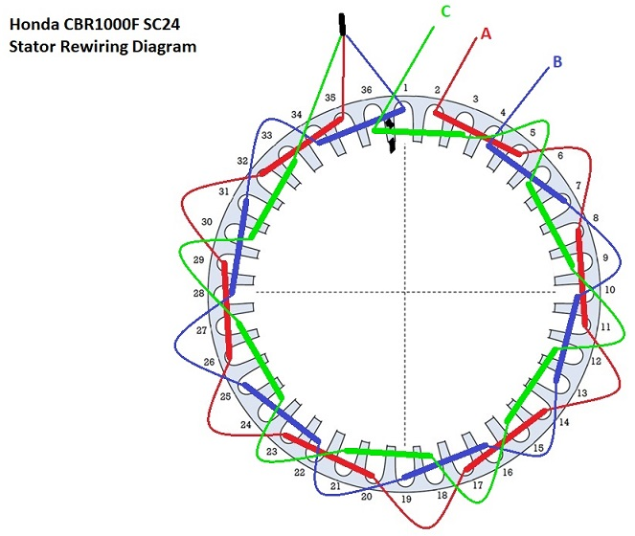

Start with phase A, next B and finally C. The A, B and C are your three yellow wires. The three other ends of the phases are all joined and soldered together and folded back down on top of the windings.

The Stator Cover Removal
First disconnect the wiring harness. Loosen and remove the three bolts holding the stator cover over the generator. The cover is full of oil so place something underneath the engine to collect the oil. It’s a tight fit so carefully use a large flat head screwdriver to provide a pry/wedge between the cover and where it bolts onto the engine. Carefully slide it off by hand. Treat your stator like brittle gold because they are impossible to replace new.
Once removed and drained, place it upside down on many layers of soft cloth. Dig out the soft covering over the machine screw heads for access. Undo the 5 machine screws shown here. Gently but firmly push the black wiring connector into the housing. Then carefully turnover. Take great care not to damage the thinly wired inner excitor core. That’s a whole other painful experience to repair.

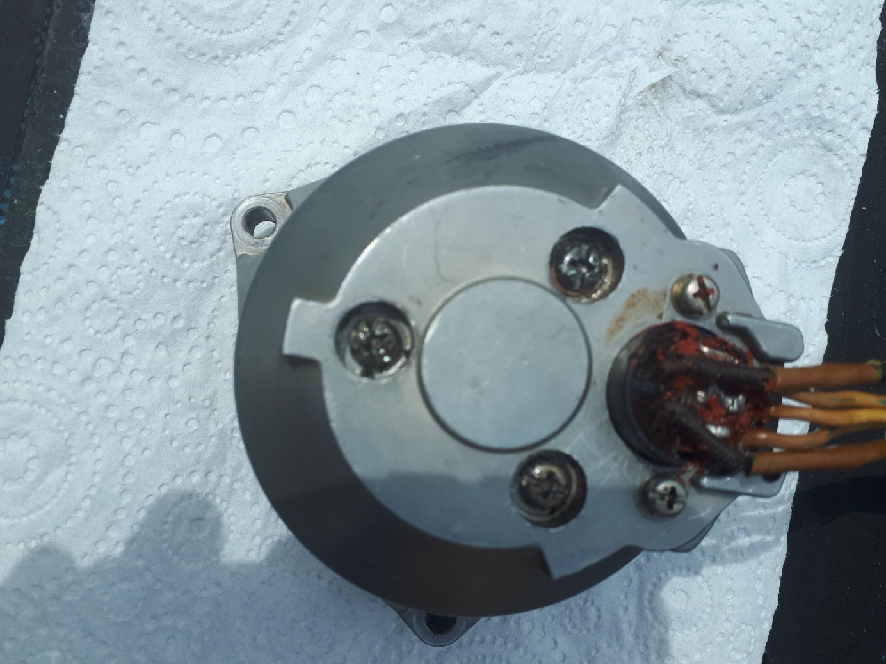

Once turned over and disassembled, you’ll see this. There is a very thin rubber seal around the lip of the stator housing that you must keep and not lose.

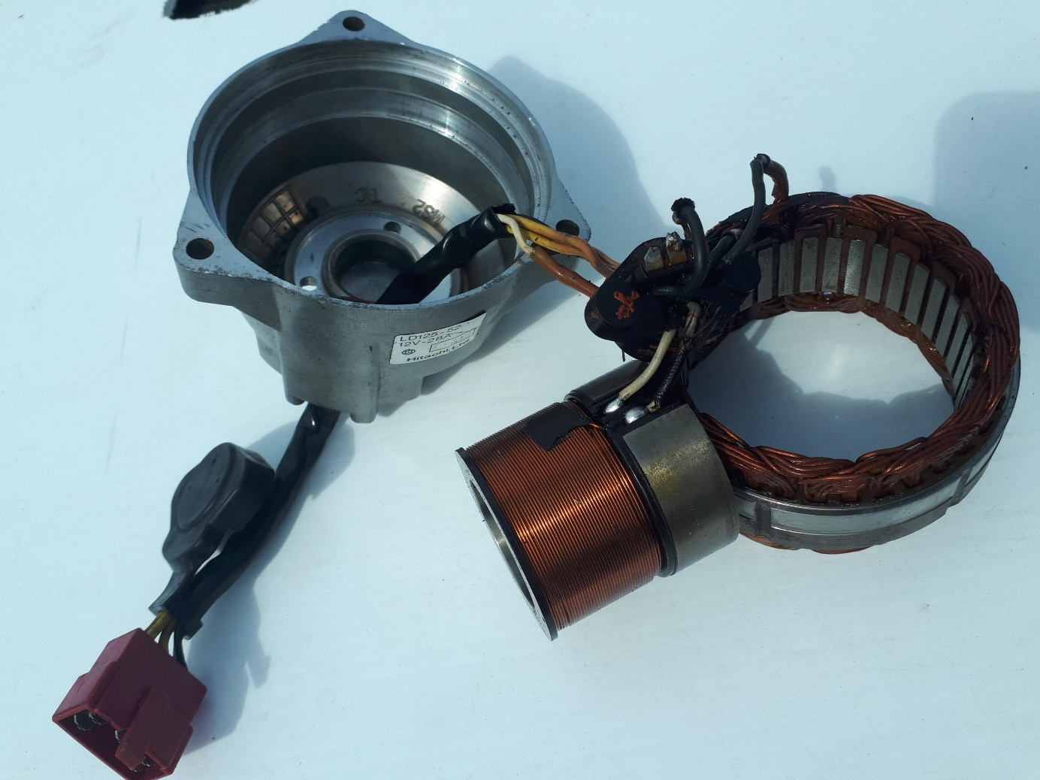
Mark each wire NOW. If you mix up the black and white wires attached to the inner excitor core, you’ll blow your 10amp starter motor fuse the instant you try and start. Also scratch mark an arrow (or many arrows) on the winding housing showing which side goes in first. This is the side that must connect with all the wiring connectors and harness. This is the side the A, B and C phases must start and end.
It took me some effort to dislodge the stator winding housing from the stator cover. DO NOT BE TEMPTED TO PUT A BENT NAIL THROUGH THE SCREW HOLES TO KNOCK IT OUT FROM BEHIND! It damages the ceramic insulation and distorts the delicate slot intervals.
Snip off the three yellow wire connections on the inside part of the black plastic connector. You now have your stator free and able to be worked on.

Removing Copper Windings
The easiest way is to cut through the copper wire and wire insulation using an angle grinder with a 1mm disc. You can count the number of individual windings clearly now – 13 per slot with 1.11mm wire. Leave about 5mm of wire on either side. Using the needle nose pliers, PUSH a wire out of the CENTRE of the slot (to avoid damaging slot insulation), then remove it from the other side. You might have to do this a couple of times per slot, all the other wires will then come loose.
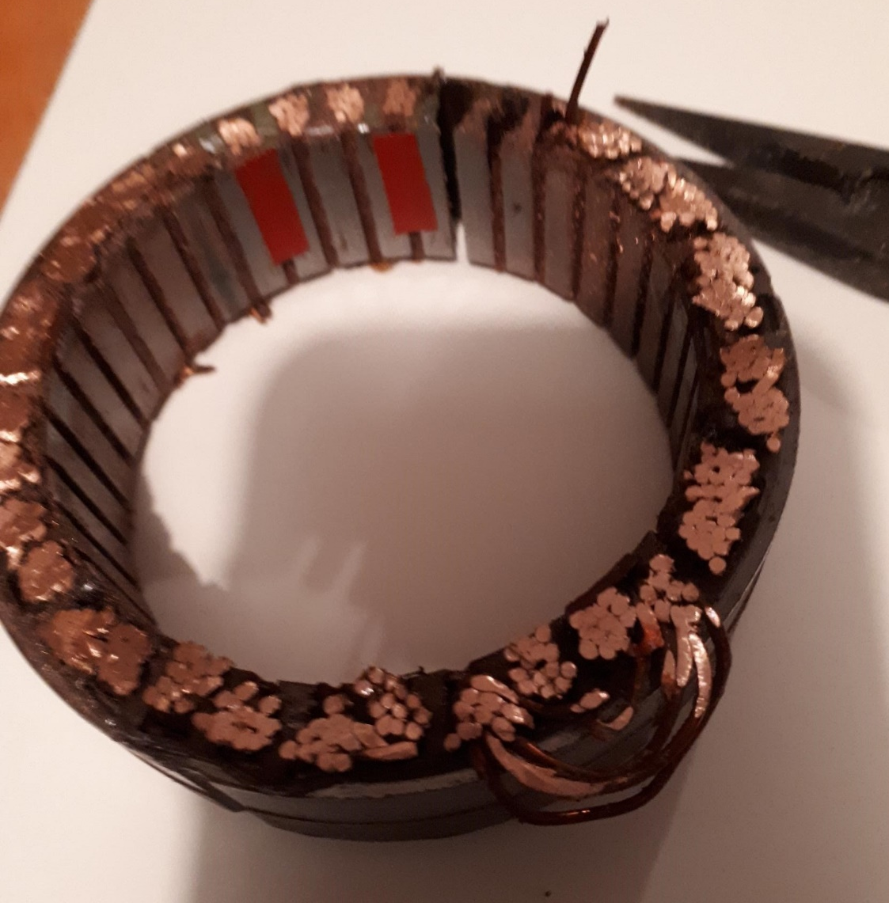

The arch shaped slot insulation pieces will also come out. These are likely to be useless now after 30 years in oil and heat.
Clean the stator housing and slots using ear buds and solvent. Take this opportunity to polish the slot faces with a Dremel. You can see where I’ve marked the first winding for Phase A for my reference.

Make a Wooden Winding Template
Firstly measure the maximum side on width of the stator including wiring. Mine was 5cm. Do not exceed this when rewinding. I made a pencil rub of the slot patterns to make sure I had the right sizes between slots and phases. Don’t forget that each winding skips 2 slots. So Phase A, for example in the wiring diagram above, the first winding covers slot 2 and slot 5. And then continues in slot 8 and slot 11.
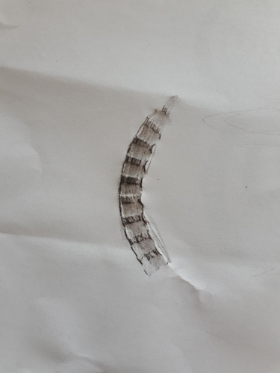
For the template, I found two hardwood offcuts 30cm long. Trimmed them to 2cm (20mm) wide and 1.5cm (15mm) deep. Then marked 6 slots 2cm (20mm) apart. Drill a couple of holes through them both and join together with a 6mm bolt or something similar.
Without the wiring, the stator is 2.5 cm thick (25mm). I went with a total winding thickness of 4cm (40mm) using a spacer on the joining bolt between the two bits of wood.
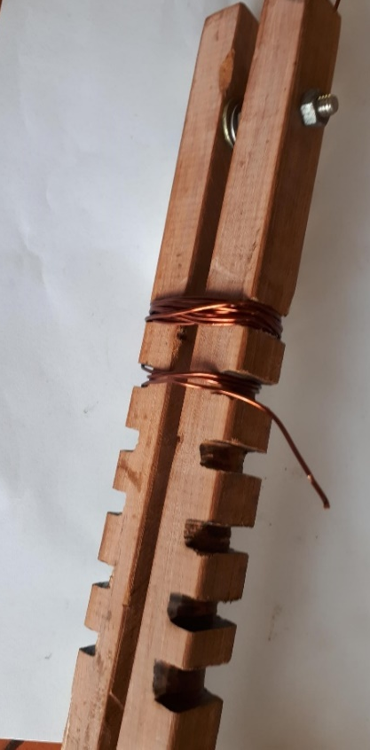

The smooth area goes into the stator housing. Maximum thickness is 5cm. The stator is 25mm thick without wiring.
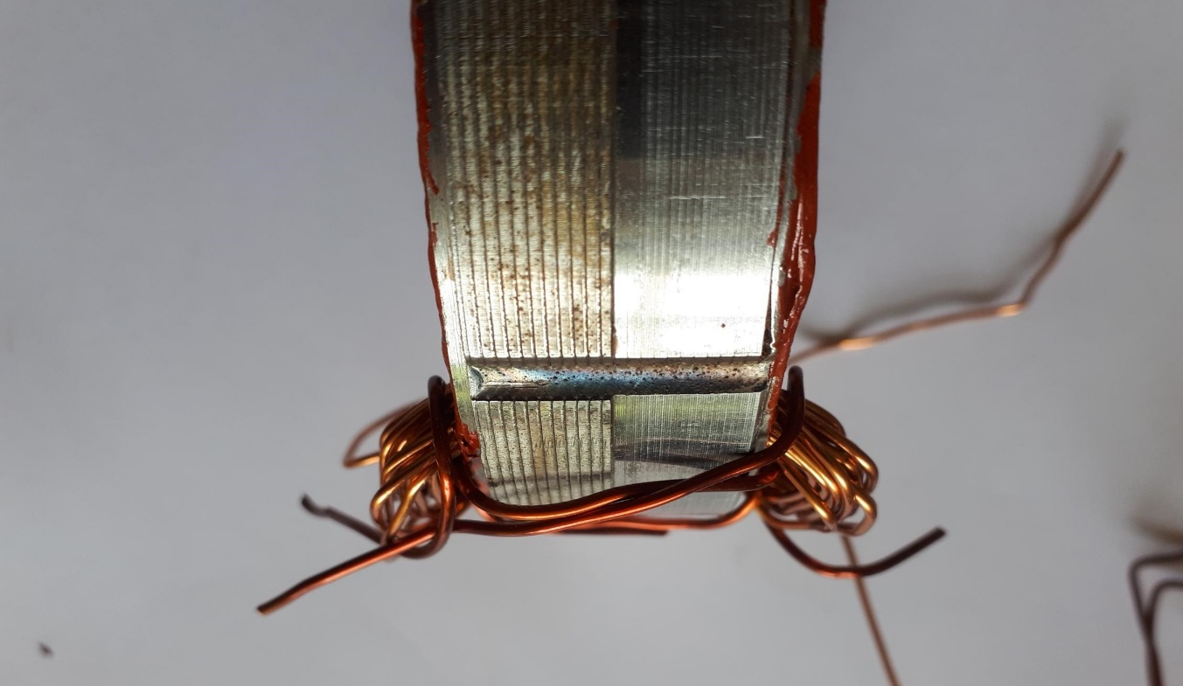
Here’s the first phase. Use cable ties to keep the wiring together otherwise you’ll end up with a mess when you remove the template.
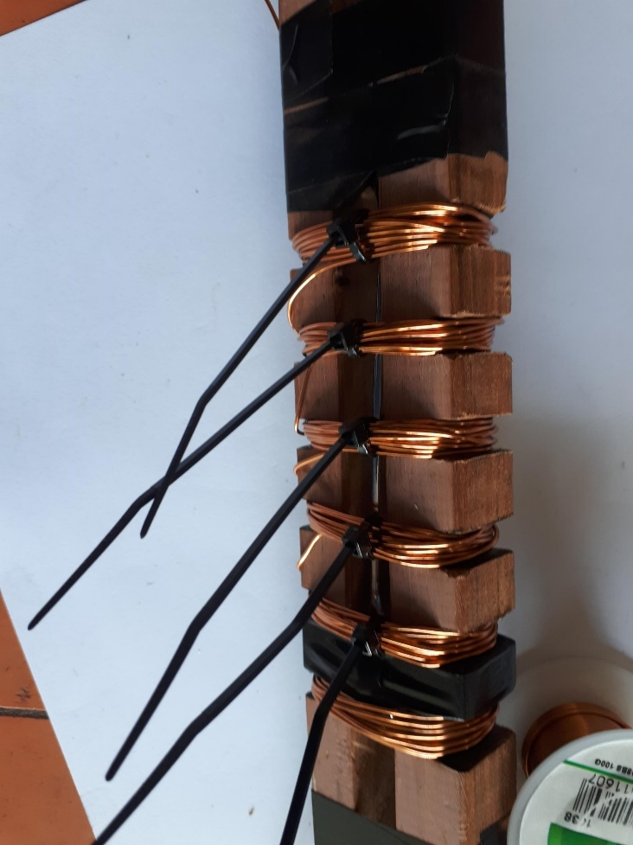

Remove the bolts and spacer to collapse the wiring template so you can slide the wiring off over the groove lips. At this point I would add additional zip ties to both sides of each winding.
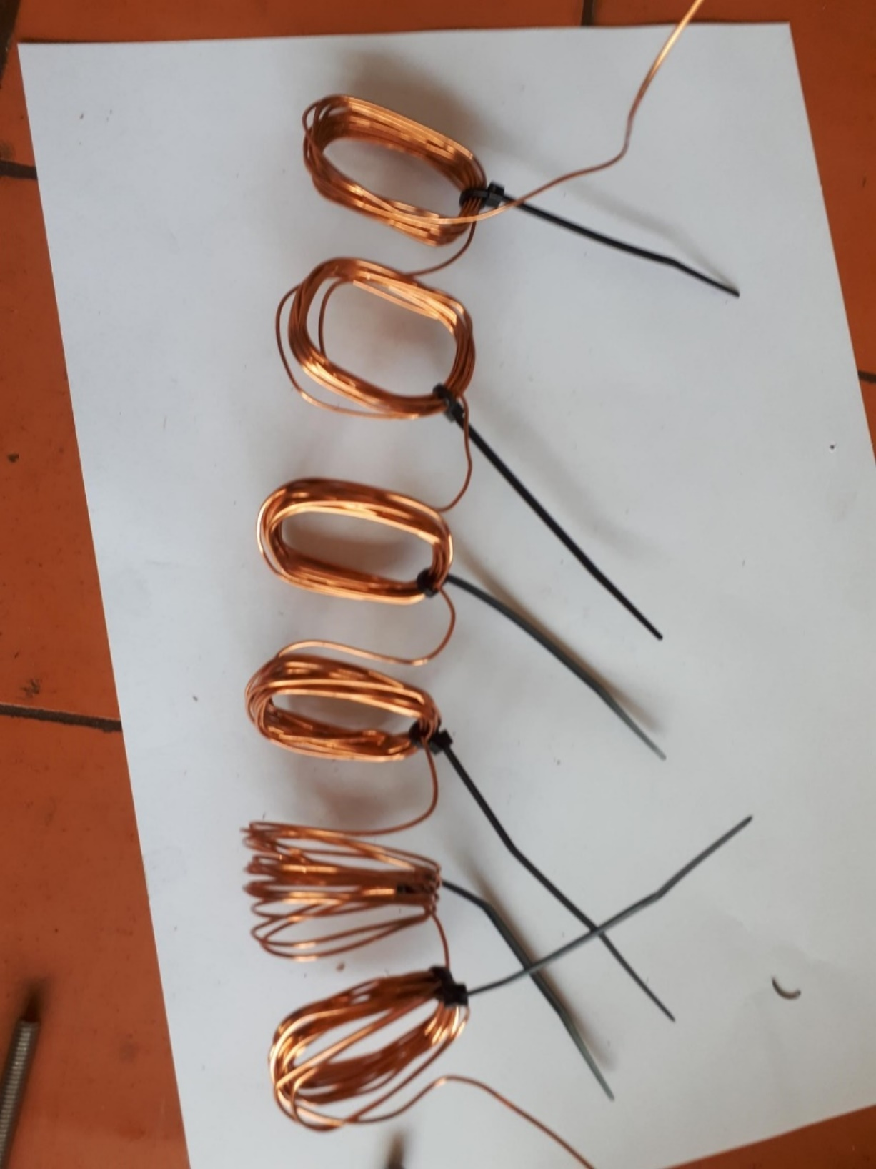

Starting The Rewinding Process
The lips of stator slots are sharp and can easily nick your new wiring coating. I tried a couple things for slot insulation. They had to be thin, oil proof and temperature rated. Grease proof paper was useless. Gasket paper no good. I settled on some pet food lids made from 0.5mm thick PP5 plastic. The tapering slot holes are 4mm wide at the face, 7mm wide at the back and 7mm deep. I made 36 individual slot insulators to fit that were 3cm (30mm) long. Needs must… If your insulation coating is undamaged then you probably don’t need to do this if you’re careful.

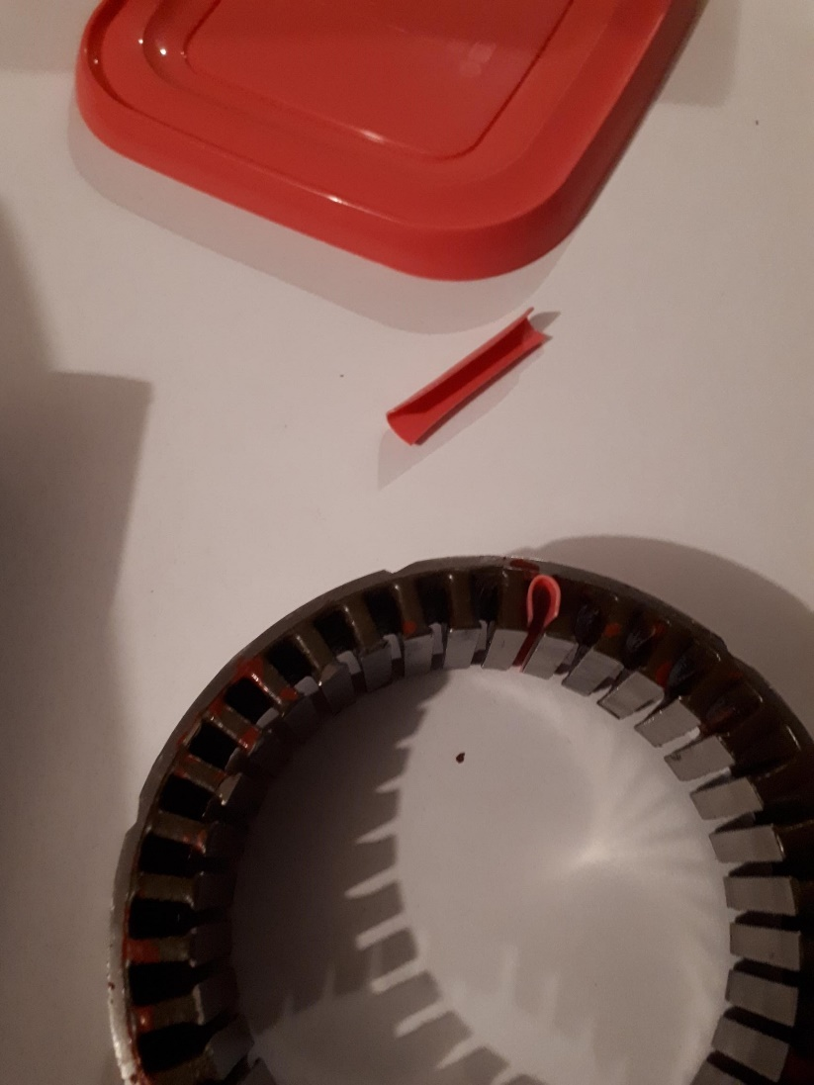

Start with phase A. Leave about 5cm to 7cm of free wire at the beginning. Mark the end with a coloured insulating tape or something.
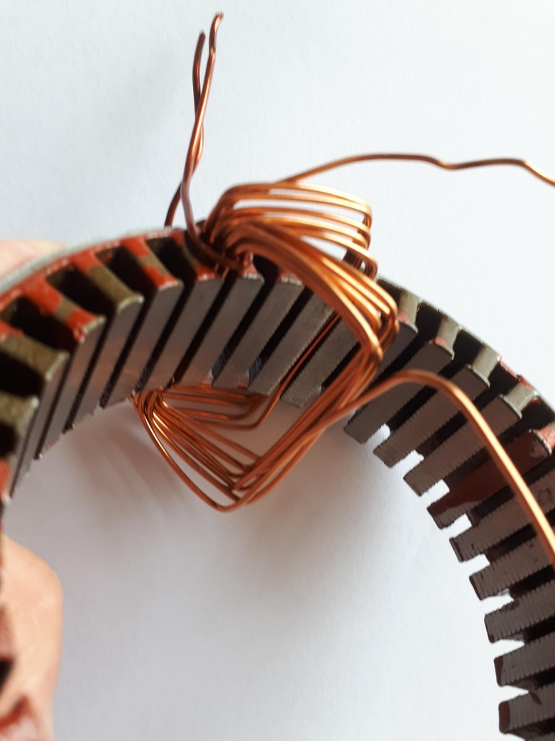
Mark the slot face between slots 1 and 36 in black as a final check for when you’re finished.
Using 4 zip ties per slot winding once you’ve got it place, two at the top and two at the bottom (i.e. one per ‘corner’). You’ll need a plastic trim removal tool - or something similarly non metallic - to make sure the wiring is bedded down well into each slot. Be patient here. Go slow. Get a bright desk lamp or something similar to assist. Take many breaks.
BIG TIP: Refer to the SC24 Stator Winding Template above before bedding down every single slot. Check it twice. Check it three times.
ANOTHER BIG TIP: Make sure the wires for each phase begin and end exactly as per the wiring diagram.
A HUGE TIP: The shiny, thinner part of the stator goes into the housing first. All the beginnings and ends to your three wires for phases A, B and C must enter/exit their slots on this side only.
It is soul destroying having to unpick the whole thing having missed a slot in error.
Check for breaks in the wire as you go. The less you manipulate the wire, the less chance of a break.
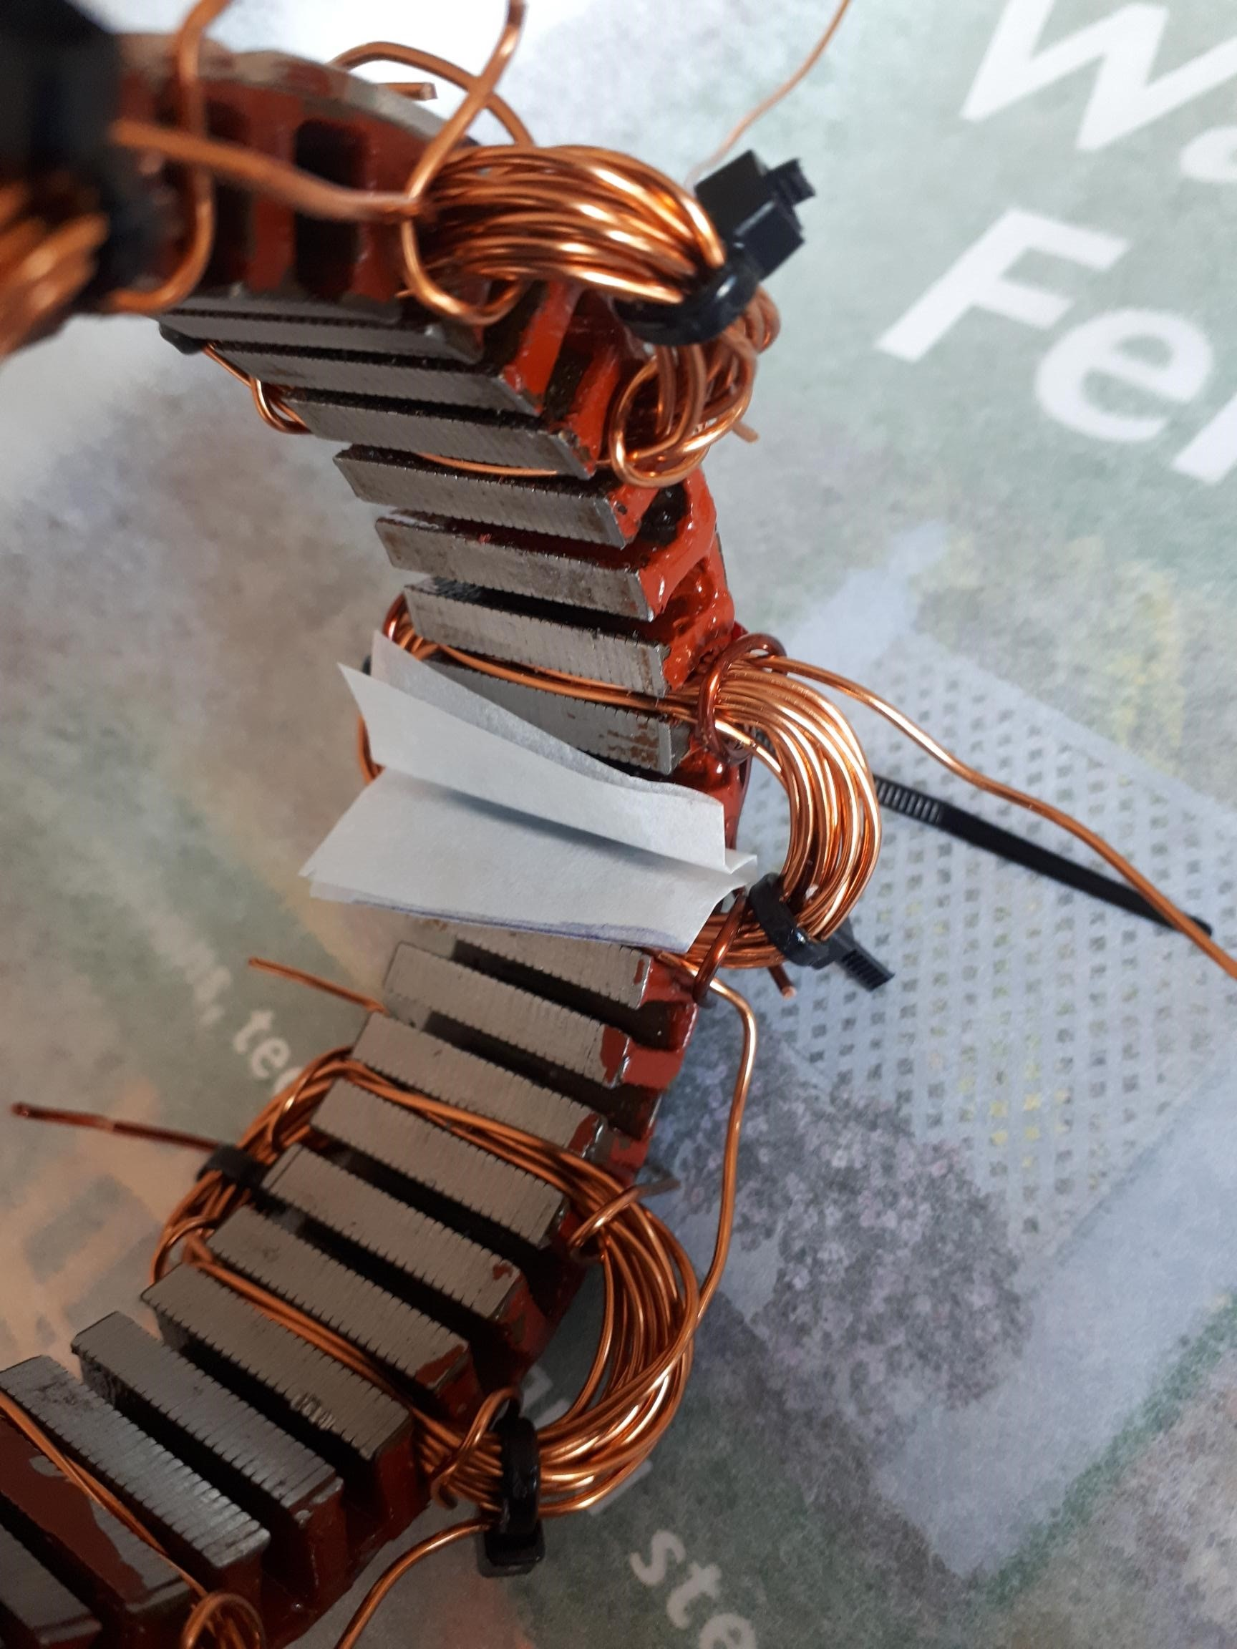

Slot Face Insulators
The likelihood of your existing arch shaped insulators being functional are remote. You can possibly use them to make templates.

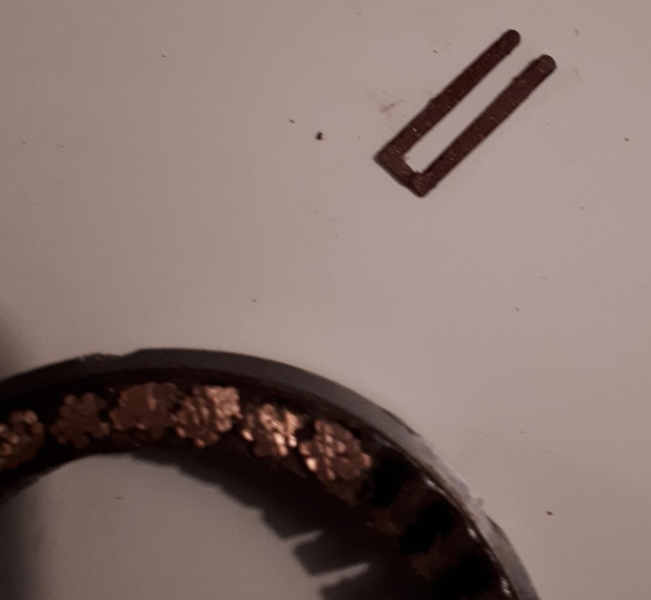

I used PCB blank 1.5 mm thick fibreglass circuit board as a material. Shaped like this below. Tapered to fit the tapered slot walls.
About 3cm (30mm) long. Very tough. Keeps the windings well away from the stator face.
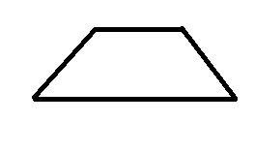

It was at this point I discovered a wire break. Plus the phase wires weren’t starting or ending in the correct places. Tried to rush it, made a hash of it and paid the price.
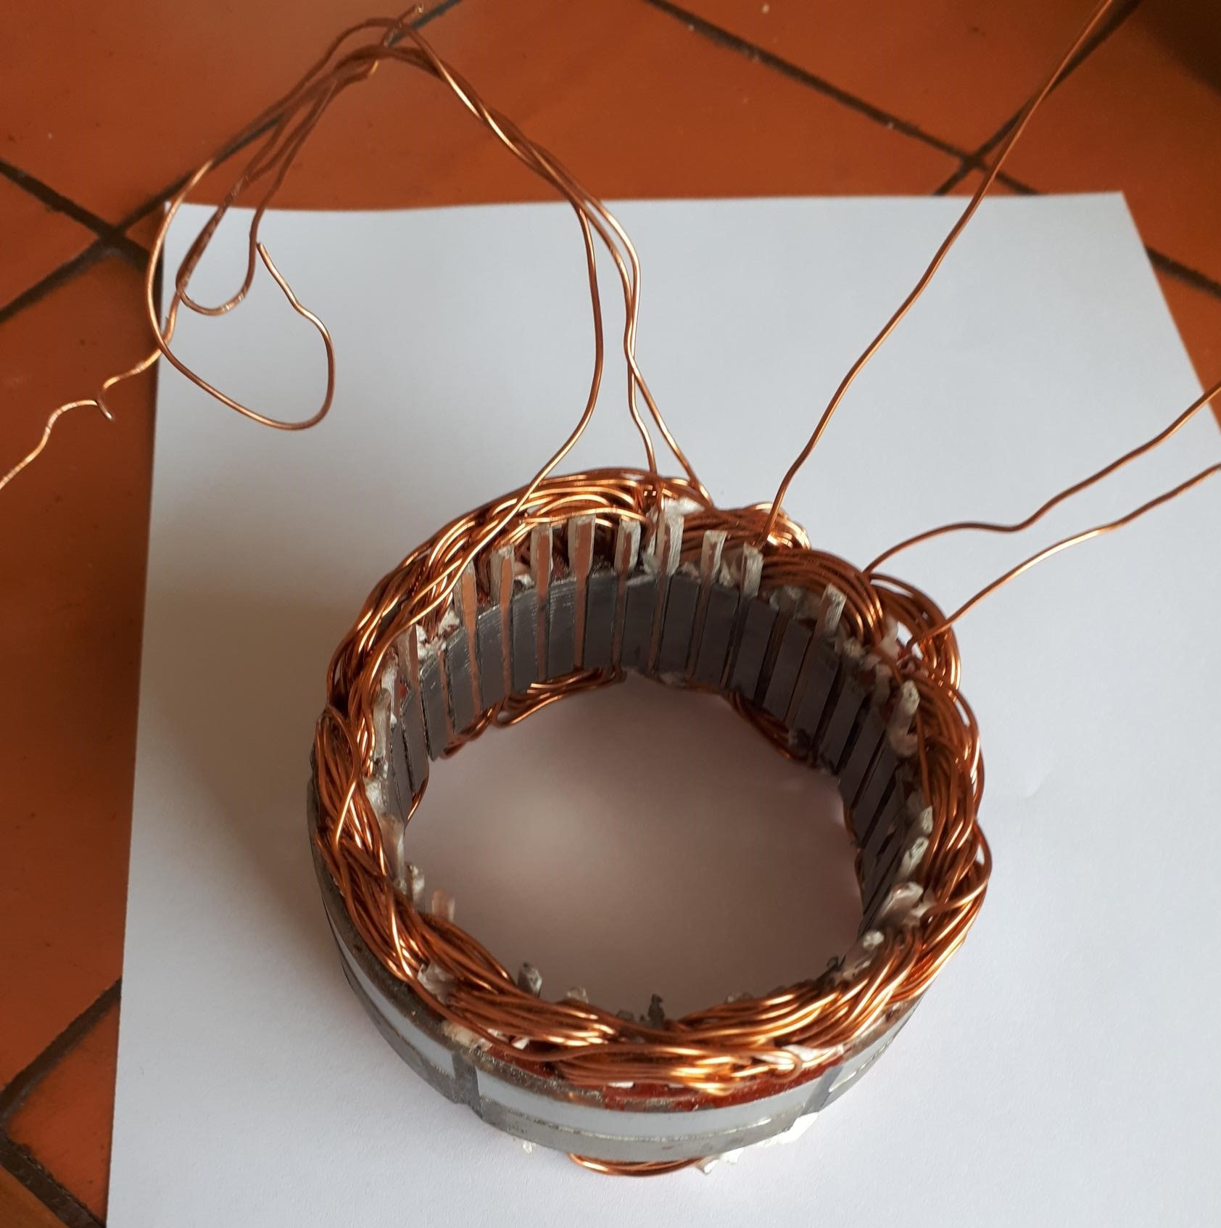

This is the final version. Two rewinds later. I gently tapped the wiring with the rubber handle of a hammer to get it into its final shape and not protruding over the internal face or external wall.
Solder the ends of the phases together. I then stripped the core out of a heavier gauge electrical cable and used the plastic sheath to cover the exposed wires. Then tied down to the windings with twine and covered everything liberally in MG Chemicals 4228 Red Insulating Varnish.
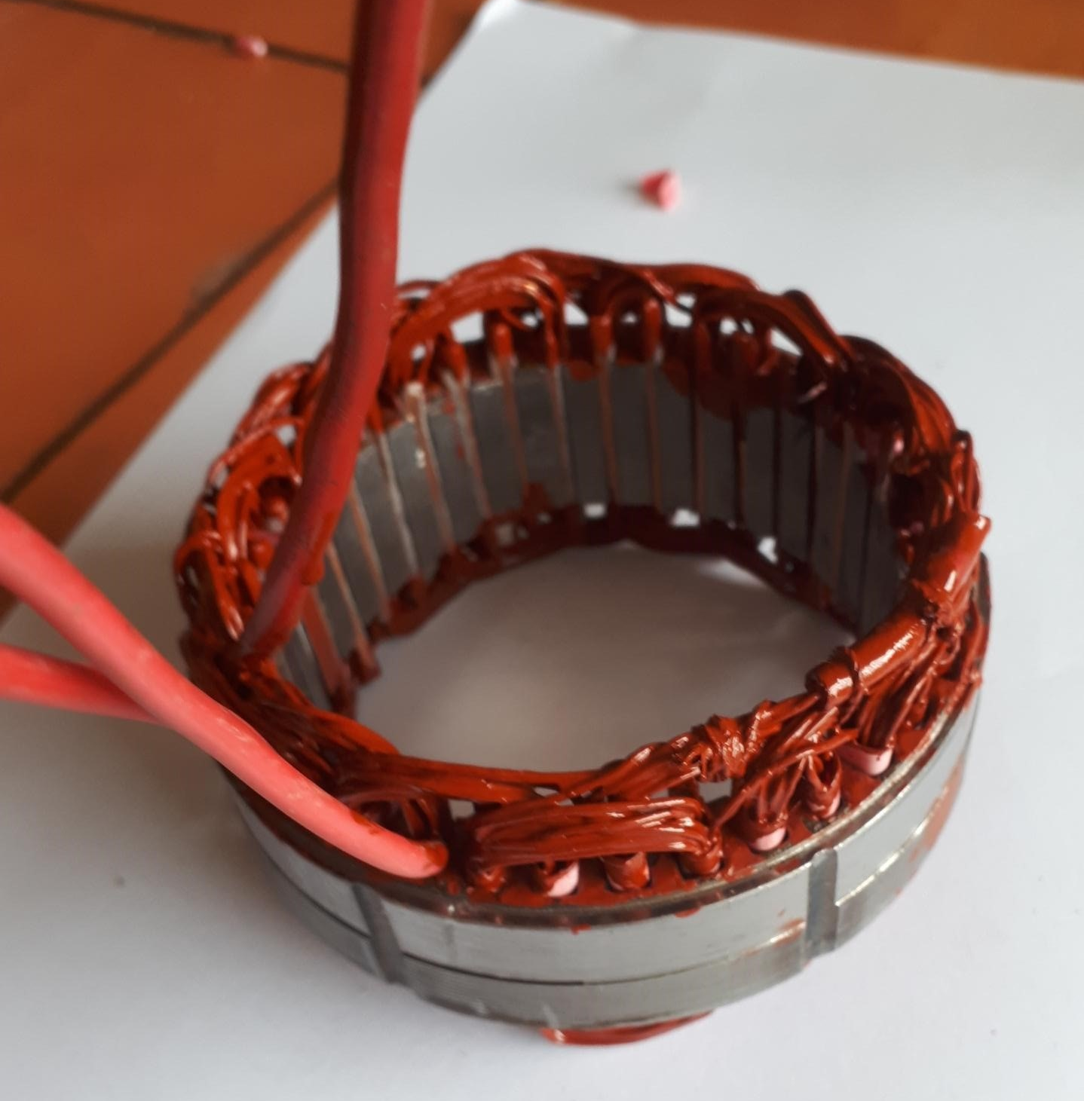

Wiring and Winding Insulation

I used MG Chemicals 4228 Red Insulating Varnish 55ml. It is ok. Seems to chip easily. Be sure to put a lot on and clean up afterwards with a Dremel. I understand that JB Weld mixed with a solvent (acetone?) could be better. And there’s also a specialist heat and oil resistant epoxy coating you can buy. As above, I also used the sheath of a stripped out electric cable to cover the ends of each of the three phases.

Re-assembly
Trim the ends of each of the three phases and solder them back on to the plastic connector.

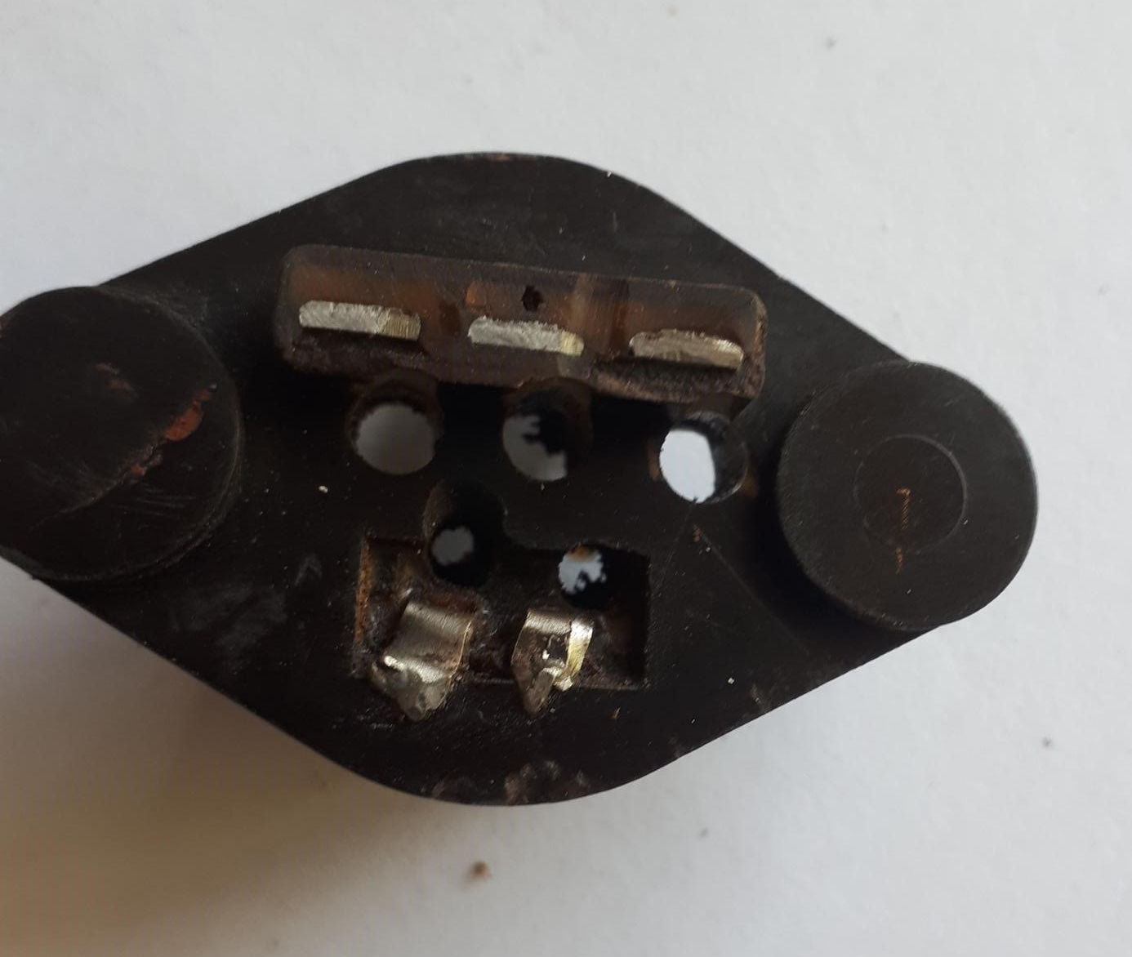

Some helpful previous owner also drilled holes through the connector and ran the wires straight through rather than soldering. This meant it leaked oil like a sieve. It must be under quite a bit of pressure in there. Don’t be tempted to do this.
Push the plastic connector firmly into place and tighten in position with the two smaller machine screws. Then the inner excitor core goes in and secure with the remaining three machine screws.
After placing the stator and inner excitor core and plastic connector back into the stator cover, double check all the wiring and windings will clear the spinning generator.
Make sure the thin rubber seal between stator and housing goes back on too. Without it, it will again leak oil. Slip the cover back on slowly. When you’ve reached a certain point, a couple taps with a rubber mallet or your fist will help. Then put the three bolts in and tighten finally, alternating between them to make sure it gets seated properly.
Checking
Before starting, check the three yellow wires with a digital meter. You should have continuity between them but not to ground. You should get something like 2.5-3Ω between each yellow wire. If you don’t get a resistance reading from one of the yellow wires, at least you’ll know which phase is the problem. Also check that there is no continuity from each of the yellow wires in turn to the battery negative terminal. The battery needs to be hooked up to the bike for this.
Fire up the engine, and change your digital meter to AC readings and measure yellow wire output. Should be AC 25 to 50 ish. Then connect up the regulator/rectifier and measure DC output at the battery. Should be 13 to 15V (ish). If you’re not getting that – your regulator/rectifier is possibly fried or you have poor wiring connections.

Good luck!

